**Extract from the Protocol No. 9 of the extraordinary meeting of the School of Public Health dated 02/23/2023**

**Participants:** Director of the School of Public Health, Professor B.M. Mamatkulov; Head of Master's Department: A.A. Imamov., associate professors: Urazaliyeva I.R., senior teacher: Adilova Z.U. assistants: Turayev B.SH., Aburahimov B.A., Nematov A.A. Tolipova G.K., Rakhmatullayeva M.K.

**Agenda:**

**Various issues:** Head of the Master's Department A.A. Imamov's visit to SPH on the attendance and learning of subjects of Master's students

**Heard:** Director of the School of Public Health, Professor B.M. Mamatkulov spoke and introduced the educational process, attendance of students and mastering of subjects at the Public Health School.

Head of the Master's Department A.A. Imamov gave his suggestions about the attendance of master students and the need to increase their pedagogic ability in mastering subjects, organizing and conducting lesson processes, and separately explaining to students with low attendance. said that the work will be carried out.

**It was decided:** Make a timely list of students with low attendance and difficulties in mastering subjects and submit them to the master's department.

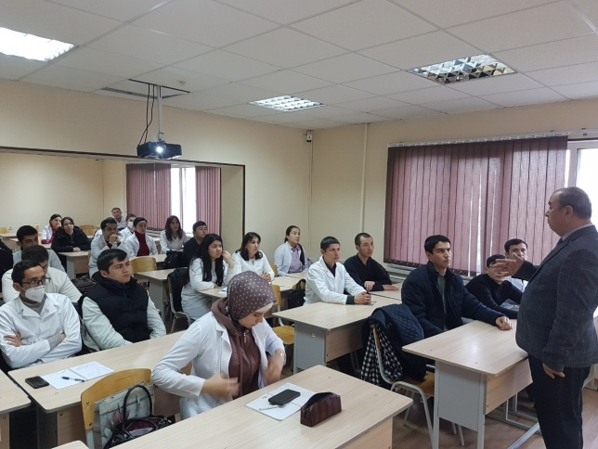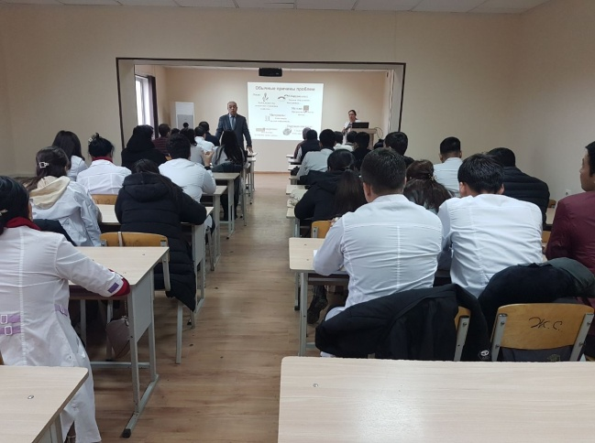

**Public health school**

**director, Ph.D. professor B.M. Mamatkulov**

**Head of the master's department A.A. Imamov**

**Secretary M.K. Rakhmatullayeva**